Selenium Assignment 02 – Locating Strategies

Learning Objectives
- Frist we learn all flavours of web element locating strategies
- Second Learn how to find locators in a web page
- Last look at what strategy we should use

Prerequisites
- HTML please refer to https://www.w3schools.com/html/
- CSS please refer to https://www.w3schools.com/css/default.asp

The Document Object Model (DOM)
The DOM is a cross-platform interface that allows representing XML-like documents (e.g., web pages, based on HTML) in a tree structure. Example 1 shows a small web page; the associated DOM tree structure in memory is represented in Figure 1. As you can see, each HTML tag (e.g., <html>, <head>, <body>, <a>, etc.) produces a node (or element) in the tree. Then, each standard HTML attribute (e.g., charset, href, etc.) produces an equivalent DOM property. Also, the text content of the HTML tags is available in the resulting tree. Languages like JavaScript use DOM methods to access and modify the tree structure. Thanks to this, web pages are dynamic and can change their layout and content in response to user events.
Example 1. Basic web page
<!DOCTYPE html>
<html>
<head>
<meta charset="utf-8">
<title>DOM example</title>
</head>
<body>
<h1>Heading text</h1>
<a href="#">Link text</a>
</body>
</html>
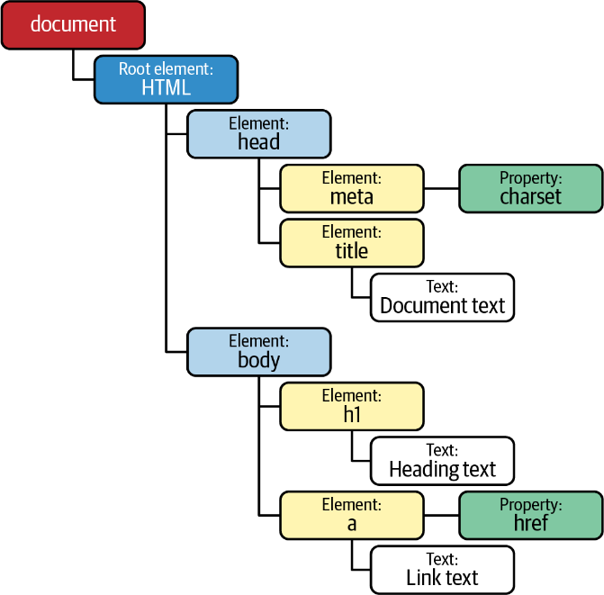
Figure 1. DOM structure generated from Example 1

WebElement Methods
One of the most relevant aspects of the Selenium WebDriver API is the ability to interact with the different elements of a web page. These elements are handled by Selenium WebDriver using the interface WebElement, an abstraction for HTML elements. There are two methods to locate WebElement in a given web page:
- First, findElement() returns the first occurrence (if any) of a given node in the Document Object Model (DOM).
- Second, find​Ele⁠ments() returns a list of DOM nodes. Both methods accept a parameter By, which specifies the location strategy
Table 1 contains a summary of the available methods in the WebElement class. You will find examples of each method in the following parts of this section.
Method | Return | Description
click() | void | Perform a mouse click (i.e., a left-click) in the current element.
submit() | void | Send a web form (when the current element is a form).
sendKeys(CharSequence... keys) | void | Simulate typing with the keyboard (e.g., in input text elements).
clear() | void | Reset the value of an input text element.
getTagName() | String | Get the tag name of the element.
getDomProperty(String name) | String | Get the value of a DOM property.
getDomAttribute(String name) | String | Get the value of the element attribute as declared in its HTML markup.
getAttribute(String name) | String | Get the value of the given HTML attribute (e.g., class) as a String. More precisely, this method attempts to get a meaningful value of the DOM property with the given name if it exists. For instance, for boolean attributes (e.g., readonly), it returns true if it exists or null if not.
getAriaRole() | String | Get element role as defined on the W3C WAI-ARIA specification.
getAccessibleName() | String | Get element accessible name as defined by WAI-ARIA.
isSelected() | boolean | Determine if a checkbox, option in a select, or radio button is selected.
isEnabled() | boolean | Determine if an element is enabled or not (e.g., a form field).
isDisplayed() | boolean | Determine if an element is visible or not.
getText() | String | Get the visible text of the element, including its sub-elements (if any).
getLocation() | Point | Get the position (x and y coordinates) from the top-left corner of the rendered element.
getSize() | Dimension | Get the width and height of the rendered element.
getRect() | Rectangle | Get the location and size of the rendered element.
getCssValue(String propName) | String | Get the value of a CSS property of the element.
getShadowRoot() | SearchContext | Get the shadow root to search in a shadow tree (see “The Shadow DOM”).
findElements(By by) | List<WebElement> | Find all subelements that match the locator within the current element.
findElement(By by) | WebElement | Find the first subelement that matches the locator within the current element.

Location Strategies
Selenium WebDriver provides eight basic location strategies, summarized in Table 2. In addition, as explained in the next subsections, there are other advanced location strategies, namely, compound and relative locators.
We specify the basic locators using the class By in the Selenium WebDriver API. The following subsections show examples of all these strategies.
Locator | Finds elements based on
Tag name | The name of HTML tag (e.g., a, p, div, img, etc.).
Link text | The exact text value displayed by a link (i.e., a HTML tag).
Partial link text | The text contained in a link (i.e., a HTML tag).
Name | The value of the attribute name.
Id | The value of the attribute id.
Class name | The value of the attribute class.
CSS selector | Patterns that follow the W3C Selectors recommendation. The original aim of CSS patterns is to select element(s) in a web page to apply CSS styles. Selenium WebDriver allows reusing these CSS selectors to find web elements and interact with them.
XPath | Queries that follow the XPath (XML Path Language) language. XPath is a W3C standard query language for selecting nodes from an XML-like document (e.g., web pages).
Table 2. Summary of the location strategies in Selenium WebDriver

Locating by HTML tag name
One of the most basic strategies for finding web elements is by tag name. Example 2 shows a test using this strategy. This test locates the text area available in the practice web form, whose HTML markup is the following:
<textarea class="form-control" id="my-textarea" rows="3"></textarea>
Example 2. Test using a locator strategy by tag name
@Test
void testByTagName() {
driver.get("https://www.w3schools.com/tags/tryit.asp?filename=tryhtml5_textarea_form ");

WebElement textarea = driver.findElement(By.tagName("textarea"));
assertThat(textarea.getDomAttribute("rows")).isEqualTo("3");
}
We use the locator By.tagName("textarea") to find this element. In this case, since this is the only text area declared on the web page, we can be sure that the method findElement() will locate this element.
We ensure the attribute rows value is the same as defined in the HTML markup.

Locating by HTML attributes (name, id, class)
Another straightforward location strategy is to find web elements by an HTML attribute, i.e., name, id, or class. Consider the following input text available in the practice web form. Notice that it includes the standard attributes class, name, id, and the nonstandard attribute myprop (included to illustrate the difference between several WebDriver methods). Example 3 shows a test using this strategy.
<input type="text" class="form-control" name="my-text" id="my-text-id" myprop="myvalue">
Example 3. Test using locators by HTML attributes (name, id, and class)
@Test
void testByHtmlAttributes() {
driver.get("https://bonigarcia.dev/selenium-webdriver-java/web-form.html");

// By name
WebElement textByName = driver.findElement(By.name("my-text"));
assertThat(textByName.isEnabled()).isTrue();

// By id
WebElement textById = driver.findElement(By.id("my-text-id"));
assertThat(textById.getAttribute("type")).isEqualTo("text");
assertThat(textById.getDomAttribute("type")).isEqualTo("text");
assertThat(textById.getDomProperty("type")).isEqualTo("text");

assertThat(textById.getAttribute("myprop")).isEqualTo("myvalue");
assertThat(textById.getDomAttribute("myprop")).isEqualTo("myvalue");
assertThat(textById.getDomProperty("myprop")).isNull();

// By class name
List<WebElement> byClassName = driver.findElements(By.className("form-control"));
assertThat(byClassName.size()).isPositive();
assertThat(byClassName.get(0).getAttribute("name")).isEqualTo("my-text");
}
We locate the text input by name.
We assert that the element is enabled (i.e., the user can type in it).
We find the same text input element by id.
This assertion (and the next two) returns the same value since the attribute type is standard, and as previously explained, it becomes a property in the DOM.
This assertion (and the next two) return different values since the attribute myprop is not standard, and for this reason, it is not available as a DOM property.
We locate a list of elements by class.
We verify the list has more than one element.
We check that the first element found by class is the same as the input text located before.

Locating by link text
The last basic locator is by link text. This strategy is twofold: locate by exact and by partial text occurrence. We use a link in the practice web form to illustrate this locator in the following HTML markup. Then, Example 4 shows a test using these locators.
<a href="./index.html">Return to index</a>
Example 4. Test using locators by text link
@Test
void testByLinkText() {
driver.get("https://bonigarcia.dev/selenium-webdriver-java/web-form.html");

WebElement linkByText = driver.findElement(By.linkText("Return to index"));
assertThat(linkByText.getTagName()).isEqualTo("a");
assertThat(linkByText.getCssValue("cursor")).isEqualTo("pointer");

WebElement linkByPartialText = driver.findElement(By.partialLinkText("index"));
assertThat(linkByPartialText.getLocation()).isEqualTo(linkByText.getLocation());
assertThat(linkByPartialText.getRect()).isEqualTo(linkByText.getRect());
}

We locate an element by its full link text.
We check its tag name is a.
We check its CSS property cursor is pointer (i.e., the style typically used for clickable elements).
We find an element by partial link text. This link will be the same as in step 1.
We verify both elements share the same position and size.

Locating by CSS selectors
The strategies we have seen so far are easy to apply but also have some limitations as below:
- First, locating by tag name can be tricky since it is likely that the same tag will occur many times on a web page.
- Next, finding elements by HTML attributes (name, id, or class) is a limited approach since these attributes are not always available. In addition, ids can be autogenerated and volatile between different sessions.
- Lastly, the location by link text is limited only to links.
To overcome these limitations, Selenium WebDriver provides two powerful location strategies: CSS selector and XPath.
There are many possibilities for creating CSS selectors. Table 3 shows a comprehensive summary with the basic CSS selectors.
Category | Syntax | Description | Example | Example explanation
Universal | * | Select all elements | * | Match all elements
Type | elementName | Select all elements with a given tag name | input | Match all <input> elements
Class | .classname | Select elements with a given class attribute | .form-control | Match all elements with class of form-control
Id | #id | Select elements with a given id attribute | #my-text-id | Match all elements with id my-text-id
Attribute | [attr] | Select elements with a given attribute | [target] | Match all elements with a target attribute
 | [attr=value] | Select elements with a given attribute and value | [target=_blank] | Match all elements with a target="_blank" attribute
 | [attr~=value] | Select elements with a given attribute containing some text value | [title~=hands] | Match all elements with a title attribute containing the word hands
 | [attr|=value] | Select elements with a given attribute equal to or starting by some value | [lang|=en] | Match all elements equal to or starting with en
 | [attr^=value] | Select elements with a given attribute starting by some value | a[href^="https"] | Match all links whose href attribute starts with https
 | [attr$=value] | Select elements with a given attribute ending by some value | a[href$=".pdf"] | Match all links whose href attribute ends with .pdf
 | [attr*=value] | Select elements with a given attribute value containing some string | a[href*="github"] | Match all links whose href attribute contains github
Table3. Basic CSS selectors
The following HTML excerpt shows the hidden input text available in the practice web form. Then, Example 5 illustrates a possible way to locate this element using a CSS selector. One advantage of this locator is that the selector will still work even when changing the attribute name in HTML markup.
<input type="hidden" name="my-hidden">
Example 5. Test using a basic locator with CSS selector
@Test
void testByCssSelectorBasic() {
driver.get("https://bonigarcia.dev/selenium-webdriver-java/web-form.html");

WebElement hidden = driver.findElement(By.cssSelector("input[type=hidden]"));
assertThat(hidden.isDisplayed()).isFalse();
}

We use a CSS selector to locate the hidden input.
We check the hidden field is not visible.
There are plenty of possibilities to create advanced CSS selectors. Table 4 shows a summary with some of them. The complete reference of CSS selectors is available in the official W3C recommendation.
Category | Syntax | Description | Example | Example explanation
Grouping | , | Group two (or more) selectors | div, span | Match both <span> and <div> elements
Combinators | (space) | Select elements that are descendants | div span | Match all <span> that are inside a <div>
 | A > B | Select elements that are direct children of another element | ul > li | Match all <li> elements nested directly inside to <ul>
 | A ~ B | Select elements sharing the same parent (i.e., siblings), and the second element follows the first (not necessarily immediately) | p ~ span | Match all <span> that follow a <p> (immediately or not)
 | A + B | Sibling elements, and the second element immediately follows the first | h2 + p | Match all <p> that immediately follows <h2>
Pseudo | : | Select a CSS pseudoclass (i.e., a special state of the selected element) | a:visited | Match all already visited links
 | :nth-child(n) | Select elements based on their position in a group (starting from the beginning) | p:nth-child(2) | Match every second <p> child
 | :not(selector) | Select elements not matching a given selector | :not(p) | Match every element different from <p>
 | :nth-last-child(n) | Select elements based on their position in a group (starting from the end) | p:nth-last-child(2) | Match every second <p> child (counting from the last child)
 | :: | Select a CSS pseudoelement (i.e., a specific part of the selected element) | p::first-line | Match the first line of all <p> elements
Table 4. Advanced CSS selectors
Consider the following piece of HTML (as usual, contained in the practice web form). As you can see, there are a couple of checkboxes: one of them is checked, and the other is not. We can determine which element is checked using the Selenium WebDriver API and CSS selectors. To that aim, Example 6 uses CSS pseudoclass.
<input class="form-check-input" type="checkbox" name="my-check" id="my-check-1" checked>
<input class="form-check-input" type="checkbox" name="my-check" id="my-check-2">
Example 6. Test using advanced locators with CSS selectors
@Test
void testByCssSelectorAdvanced() {
driver.get("https://bonigarcia.dev/selenium-webdriver-java/web-form.html");

WebElement checkbox1 = driver.findElement(By.cssSelector("[type=checkbox]:checked"));
assertThat(checkbox1.getAttribute("id")).isEqualTo("my-checkbox-1");
assertThat(checkbox1.isSelected()).isTrue();

WebElement checkbox2 = driver.findElement(By.cssSelector("[type=checkbox]:not(:checked)"));
assertThat(checkbox2.getAttribute("id")).isEqualTo("my-checkbox-2");
assertThat(checkbox2.isSelected()).isFalse();
}
We use the pseudoclass checked to locate clicked checkboxes.
We check the element id is as expected.
We confirm the selected is checked.
We use the pseudoclass checked and the operator not to locate default checkboxes.
We check the element id is as expected.
We confirm the selected is unchecked.

Locating by XPath
XPath (XML Path Language) is a powerful way of navigating to the DOM of XML-like documents, such as HTML pages. It includes over two hundred built-in functions to create advanced queries to select nodes. There are two types of XPath queries. First, absolute queries use the symbol slash (/) to traverse the DOM from the root node. For example, considering the basic HTML page in Example 5, to select the link element present in this page using this approach, we need the following XPath query:
/html/body/a
Absolute XPath queries are easy to create, but they have a relevant inconvenience: any minimal change in the page layout would make a locator built with this strategy fail. For this reason, as a general rule, the usage of absolute XPaths is discouraged. Instead, relative queries are more convenient.
The general syntax for relative XPath queries is as follows:
//tagname[@attribute='value']
Example 7 shows a test with an XPath locator to select the hidden field in the practice web.
Example 7. Test using a basic locator with XPath
@Test
void testByXPathBasic() {
driver.get("https://bonigarcia.dev/selenium-webdriver-java/web-form.html");

WebElement hidden = driver.findElement(By.xpath("//input[@type='hidden']"));
assertThat(hidden.isDisplayed()).isFalse();
}
We locate the hidden field in the practice web.
We verify this element is not visible to the user.
The real power of XPath comes from its built-in functions. Table 5 contains some of the most relevant XPath functions. You can find the complete XPath reference in the W3C XPath Recommendations.
Category | Syntax | Description | Example | Example explanation
Attributes | contains(@attr, 'string') | Check if an attribute contains a string | //a[contains(@href, 'github')] | Match links with href containing github
 | starts-with(@attr, 'string') | Check if an attribute starts with a string | //a[starts-with(@href, 'https')] | Match all links using HTTPS
 | ends-with(@attr, 'string') | Check if an attribute end with a string | //a[ends-with(@href, https)] | Match all links to PDF documents
Text | text()='string' | Locate elements based on text content | //*[text()=click] | Match all elements with the text click
Child nodes | [index] | Locate children elements | //div/*[0] | First child of a <div>
Boolean | or | Logic operator or | //@type='submit' or @type='reset'] | Match buttons to submit and clear forms
 | and | Logic operator and | //@type='submit' and @id ='my-button'] | Match submit buttons with a given id
 | not() | Logic operator not | //@type='submit' and not(@id ='my-button')] | Match submit buttons different to a given id
Axes (used to locate relative nodes) | following::item | Nodes that come after the current one | //*[@type='text']//following::input | Match all input fields after the first text input
 | descendant::item | Select descendant elements (child, etc.) of current node | //*[@id='my-id']//descendant::a | Match all descendant links from a given parent node
 | ancestor::item | Select ancestor elements (parent, etc.) of current node | //input[@id='my-id']//ancestor::label | Match all antecedent labels from a given input text
 | child::item | Select children elements of current node | //*[@id='my-id']//child::li | Match all list element under a given node
 | preceding::item | Select all nodes that come before the current one | //*[@id='my-id']//preceding::input | Match all input before a given node
 | following-sibling::item | Select following nodes that come before the current one | //*[@id='my-id']//following-sibling::input | Match the next input before a given node
 | parent::item | Select parent of the current node | //*[@id='my-id']//parent::div | Match the parent div element of a given node
Table 5. Summary of relevant XPath built-in functions
Example 8 shows how to use XPath locators for the radio buttons available in the practice web form. The HTML markup for these radio buttons is:
<input class="form-check-input" type="radio" name="my-radio" id="my-radio-1" checked>
<input class="form-check-input" type="radio" name="my-radio" id="my-radio-2">
Example 8. Test using advanced locators with XPath
@Test
void testByXPathAdvanced() {
driver.get("https://bonigarcia.dev/selenium-webdriver-java/web-form.html");

WebElement radio1 = driver.findElement(By.xpath("//*[@type='radio' and @checked]"));
assertThat(radio1.getAttribute("id")).isEqualTo("my-radio-1");
assertThat(radio1.isSelected()).isTrue();

WebElement radio2 = driver.findElement(By.xpath("//*[@type='radio' and not(@checked)]"));
assertThat(radio2.getAttribute("id")).isEqualTo("my-radio-2");
assertThat(radio2.isSelected()).isFalse();
}

We use XPath to locate the checked radio buttons.
We check the element id is as expected.
We confirm the selected is checked.
We use XPath to locate the unchecked radio buttons.
We check the element id is as expected.
We confirm the selected is unchecked.
TIP
“What Strategy Should You Use?” provides a comparison between CSS selectors and XPath and gives some hints for selecting one or another locator strategies.

Finding Locators on a Web Page
There are different tools we can use to help generate locators for our WebDriver tests. This section shows how to use the main features of the built-in developer tools in major browsers, i.e., Chrome DevTools for Chromium-based browsers (e.g., Chrome and Edge) and Firefox Developer Tools (for Firefox).
You can open both of these developer tools by right-clicking on the portion of the web page UI that you want to test and then selecting the option menu Inspect. Figure 3 shows a screenshot of Chrome DevTools placed at the bottom of the browser (you can move it if you want).
Developer tools provide different ways to locate elements in a web page. First, we use the element selector by clicking on the icon (an arrow over a box) in the upper left corner of the developer tools pane. Then, we can move the mouse over the page to highlight each web element and inspect the elements panel to check their markup, attributes, etc.
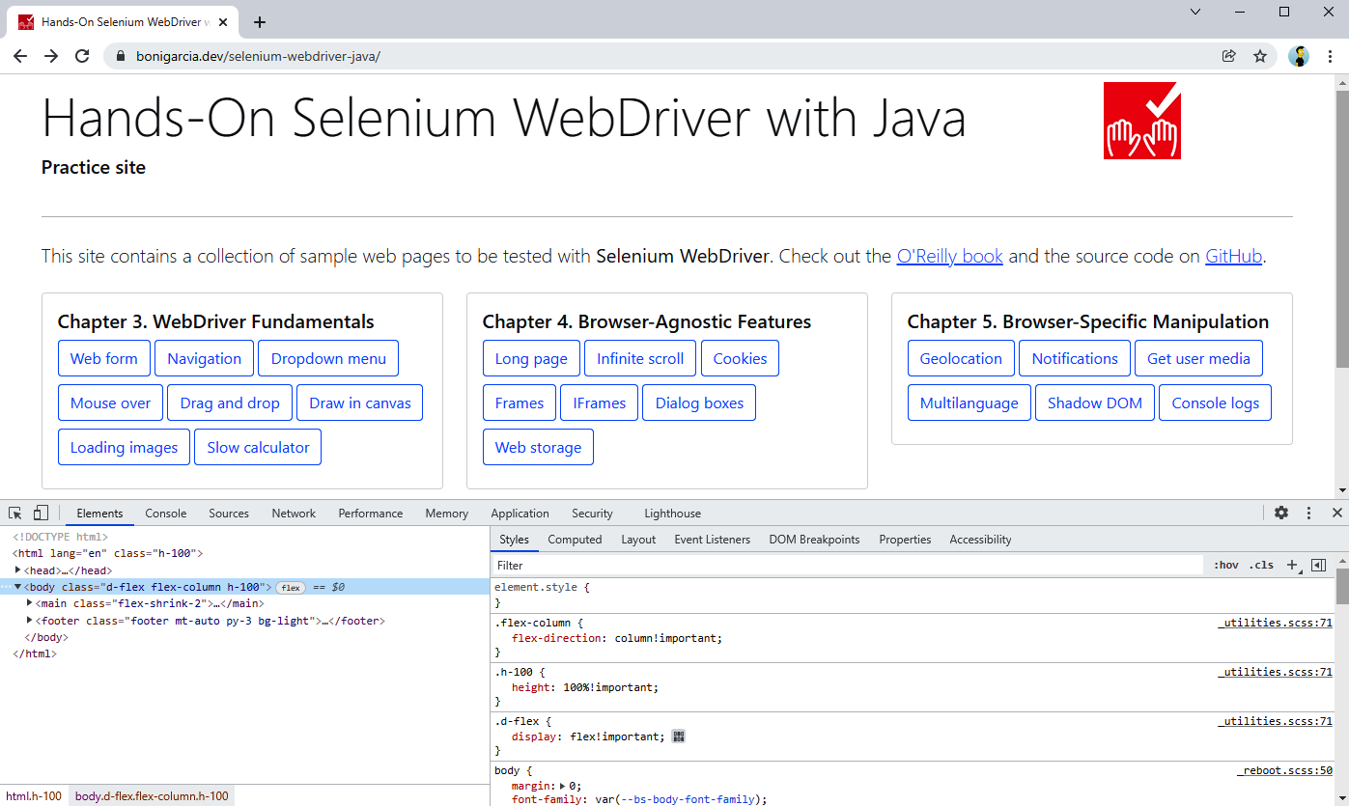
Figure 3. Use of Chrome DevTools while navigating the practice site
In the same view, we can use the tool to copy its CSS or XPath selector by right-clicking on the element and then selecting the menu option “Copy.” This mechanism allows getting the full CSS or XPath selector. It can be the first approach to generate a locator quickly, although I do not recommend using these locators directly since they tend to be brittle (i.e., linked to the current page layout) and are hard to read.
To create robust CSS or XPath locators, we need to think about the specific characteristics of the web pages we are working with and create a custom selector based on that knowledge. Again, the developer tools can help us in this task. We can press the key combination Ctrl + F to search by string, CSS selector, or XPath in Chrome DevTools. Figure 4 shows an example of this feature in action.
Notice we are using the practice web form, and we type the string #my-text-id, which corresponds to the element with a given id using a CSS selector. DevTools found the web element on the page and highlighted it.
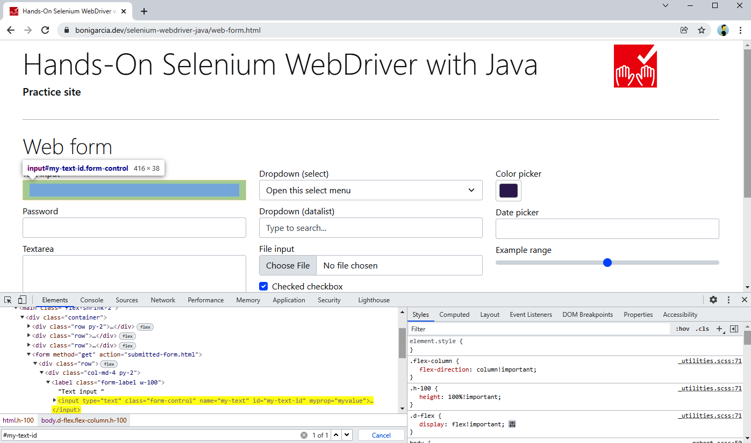
Figure 4. Searching CSS selector in Chrome DevTools
We can use a similar approach in Firefox. We need to use the console panel and type $$("css-selector") for searching by CSS selector or $x("xpath-query") for XPath queries. Figure 5 shows how to locate the first input text element of the practice web form by id, using a CSS selector and an XPath query.
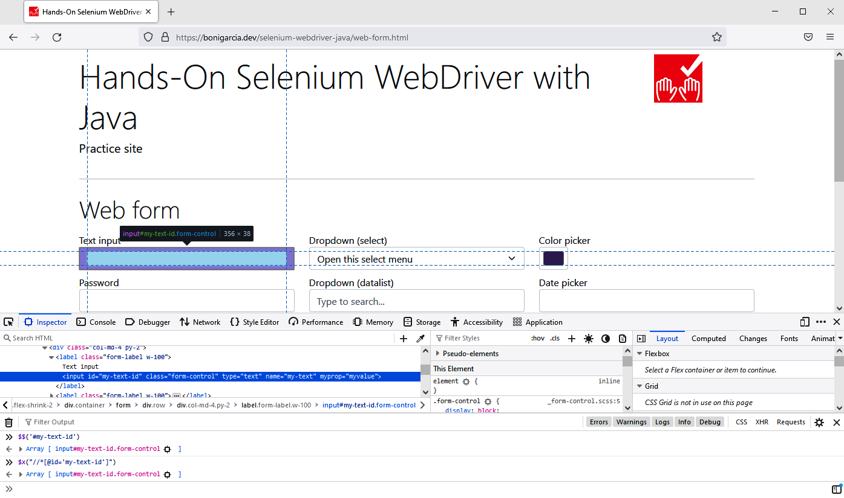
Figure 5. Searching CSS selector and XPath in Firefox Developer Tools

Compound Locators
The Selenium WebDriver API has several support classes that enable the composition of the different locator types we have seen. These classes are:
ByIdOrName(String idOrName)
It seeks by id, and if that is not available, it seeks by name.
ByChained(By... bys)
It seeks elements in a sequence (i.e., the second one should appear inside the first one, and so on).
ByAll(By... bys)
It seeks elements that match a number of location strategies (following an and logic condition for these locators).
Example 13 shows a test using ByIdOrName. This test looks for the following file-select field available in the practice web form. Notice that this field specifies the attribute name (but not id).
<input class="form-control" type="file" name="my-file">
Example 13. Test using by id or name compound locator
@Test
void testByIdOrName() {
driver.get("https://bonigarcia.dev/selenium-webdriver-java/web-form.html");

WebElement fileElement = driver.findElement(new ByIdOrName("my-file"));
assertThat(fileElement.getAttribute("id")).isBlank();
assertThat(fileElement.getAttribute("name")).isNotBlank();
}

We use a locator by id or name.
We check the element has the attribute name.
We verify the absence of the attribute name in the same element.

Example 14 shows two tests illustrating the difference between ByChained and ByAll. Both locators use the practice web form again. If you inspect its source code, you will notice that there are three single <div class="row"> inside the <form>.
Example 14. Test using by chained and by all compound locators
@Test
void testByChained() {
driver.get("https://bonigarcia.dev/selenium-webdriver-java/web-form.html");

List<WebElement> rowsInForm = driver.findElements(
new ByChained(By.tagName("form"), By.className("row")));
assertThat(rowsInForm.size()).isEqualTo(1);
}

@Test
void testByAll() {
driver.get("https://bonigarcia.dev/selenium-webdriver-java/web-form.html");

List<WebElement> rowsInForm = driver.findElements(
new ByAll(By.tagName("form"), By.className("row")));
assertThat(rowsInForm.size()).isEqualTo(5);
}

We use the locator using ByChained.
We find one element since only one row element is within the form.
We use the locator using ByAll.
We find five elements, since the locator matches a <form> element plus four <div class="row"> available on the page.

Relative Locators
Selenium WebDriver version 4 incorporates a new way to find elements in a web page: relative locators. These new locators aim to find web elements relative to another known element. This feature is based on the CSS box model. The model determines that each element of a web document is rendered using a rectangular box. Figure 6 shows an example of this box model for a given web element in the practice form.
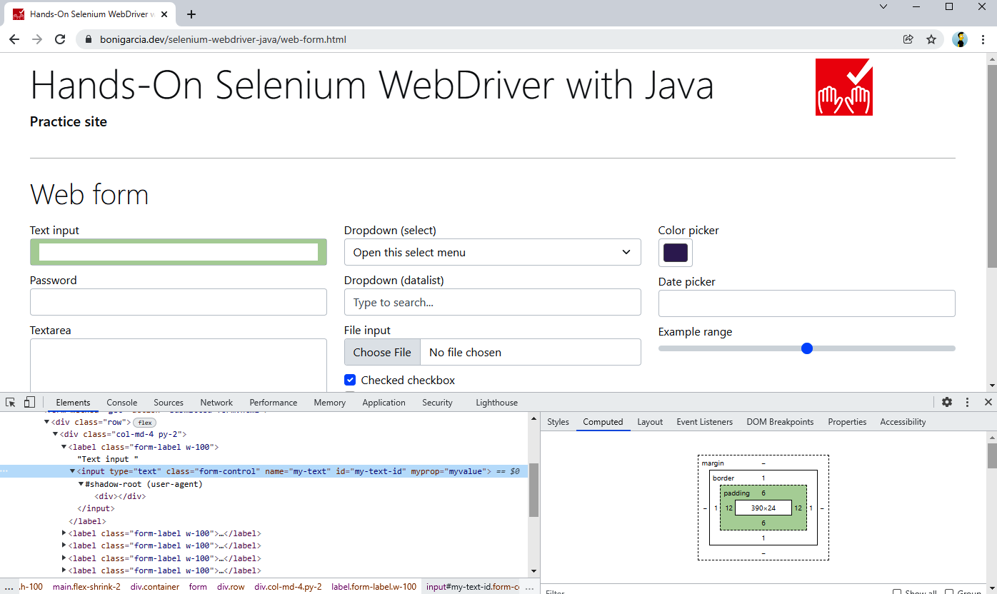
Figure 6. Practice form showing the box model of a web element
Using this box model, the relative locators available in the Selenium WebDriver API allow finding elements in relation to the position of another web element. To this aim, first, we need to locate that web element using the standard location strategies (e.g., by id, name, attribute, etc.). Then, we need to specify the locator type obtained by proximity to the original web element using the static method with of the class RelativeLocator. As a result, we get a RelativeBy object, which extends the abstract class By, used in the standard locator strategies. A RelativeBy object provides the following methods to carry out relative location:
above()
Finds element(s) located on the top of the original element.
below()
Finds element(s) located under the original element.
near()
Finds element(s) located close to the original element. The default distance to consider an element near to some other is one hundred pixels. This locator is overloaded to specify another distance.
toLeftOf()
Finds element(s) located at the left side of the original element.
toRightOf()
Finds element(s) located at the right side of the original element.
Example 15 shows a basic test using relative locators. Once again, we use the practice web form to illustrate this feature.
Example 15. Test using relative locators
@Test
void testRelativeLocators() {
driver.get("https://bonigarcia.dev/selenium-webdriver-java/web-form.html");

WebElement link = driver.findElement(By.linkText("Return to index"));
RelativeBy relativeBy = RelativeLocator.with(By.tagName("input"));
WebElement readOnly = driver.findElement(relativeBy.above(link));
assertThat(readOnly.getAttribute("name")).isEqualTo("my-readonly");
}

We locate the link whose text is Return to index.
We specify the relative locator type, which will be by tag name the input.
We use a relative locator to find a web element (which should be an input filed) above the original web element (i.e., a link).
We verify the element above the reference link is a read-only field (see Figure 2 to double-check it).
WARNING
Relative locators can be helpful for finding elements based on the relative position of other elements. On the other hand, this strategy can be very sensitive to page layout. For example, you need to be careful when using relative locators in responsive pages since the layout can vary depending on the viewport.

What Strategy Should You Use?
In this section, we review the different alternatives the Selenium WebDriver API allows for locating elements in a web page. This topic is one of the most fundamental routines for browser automation with Selenium WebDriver. Maybe you are asking yourself: What is the best strategy I should use? As Dr. Alfred Lanning (character in the novel and movie I, Robot) would say: “That, detective, is the right question.” In my opinion, that is a difficult question, and it has no simple answer. In other words, the answer to this question could be “it depends.” This section presents several hints for identifying a suitable locator strategy for common use cases. First, Table 8 compares the different locating strategies.
Locator | Pros | Cons | Typical use case
By attribute (id, name, class) | Easy to use | These attributes are not always available | Elements that define these attributes immutably (i.e., it does not change dynamically)
By link text (total or partial) | Easy to use | Only available for links | For text links
By tag name | Easy to use | Hard to select one specific element when the tag repeatedly appears on the page | When the tag is unique, or the resulting DOM node has a fixed position
By CSS selector or by XPath | Very powerful | It is not easy to write robust selectors | For complex locators
Compound locators | Easy way to compose existing locators | Limited to specific situations | When looking for id or name (ByIdOrName), when looking for nested elements (ByChained), and when using several strategies at the same time (ByAll)
Relative locators | Human language approach | It needs to be combined with other locators | Find element based on the relative position (above, below, near, etc.) of a known element
Table 8. Pros, cons, and typical use cases of the different locating strategies
As you can see in this table, CSS selectors and XPath share the same pros, cons, and use cases. Does it mean these strategies are the same? The answer is no. Both are very powerful and allow the creation of complex locators. Nevertheless, there are relevant distinctions between them. Table 9 summarizes these differences.
XPath | CSS selector
XPath allows bidirectional location, i.e., the traversal can be from parent to child and vice versa | CSS allows one-directional locations, i.e., the traversal is from parent to child only
XPath is slower in terms of performance | CSS has faster performance than XPath
XPath allows the identification of visible text on the screen using the text() function | CSS does not allow locating elements by its text content
Table 9. Some differences between XPath and CSS selector
To better illustrate the difference between XPath and CSS selectors, Table 10 compares specific locators using both strategies.
Locator | XPath | CSS selector
All elements | //* | *
All <div> elements | //div | div
Element by id | //*[@id='my-id'] | #my-id
Element by class | //*[contains(@class='my-class')] | .my-class
Element with attribute | //*[@attr] | *[attr]
Find by text in a <div> | //div[text()='search-string'] | Not possible
First child of a <div> | //div/*[1] | div>*:first-child
All <div> with a link child | //div[a] | Not possible
Next element in a <div> | //div/following-sibling::*[1] | div + *
Previous element of a <div> | //div/preceding-sibling::*[1] | Not possible
Table 10. Examples comparing XPath and CSS selector
In conclusion, we can see that XPath provides the most general strategy. Nevertheless, there are some cases in which the CSS selectors offer a friendlier syntax (e.g., locating by id or class) and better general performance.

Exercise
Let’s get our hands dirty and look at a practical use case from W3School web. A nondefault element in the practice web is the date picker. As its name suggests, this element provides a handy way to select dates using a web GUI. Since the CSS framework used in the practice site is Bootstrap. This date picker is attached to an input field. When the user clicks on this field, a calendar appears on the web page (see Figure 7). The user can select a given date by clicking the preferred date by navigating to the different days, months, and years.
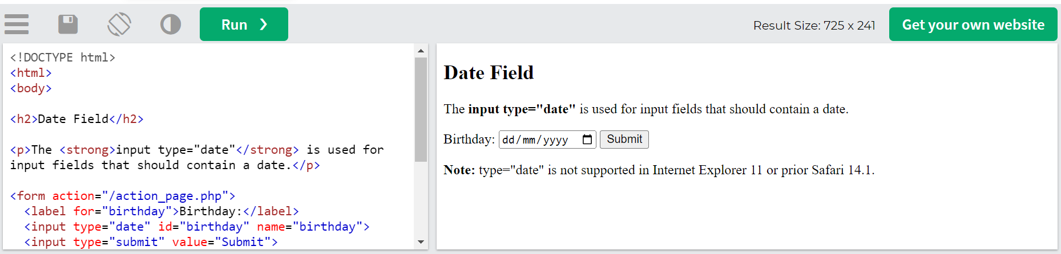
Figure 7. Date picker in the practice web form
We want to implement an automated test using Selenium WebDriver that selects the current day and month but the previous year by interacting with the date picker GUI. Example 16 shows some logical step for you to fellow to achieve the resulting implementation.
TIP
To follow this example, I recommend you open the practice web form (see URL in the code example) in your browser and use the developer tools to inspect the internal elements of the date picker selector, paying attention to the different selector strategies used.
Example 16. Test interacting with a date picker
@Test
void testDatePicker() {
driver.get("https://www.w3schools.com/html/tryit.asp?filename=tryhtml_input_date");

// Get the current date from the system clock

// Click on the date picker to open the calendar

// Click on the current month by searching by text

// Click on the left arrow using relative locators

// Click on the current month of that year

// Click on the present day in that month

// Get the final date on the input text

// Assert that the expected date is equal to the one selected in the date picker
}

Get the current date from the system clock. We use the standard java.time API for this.
Click on the date picker to open the calendar. We use a locator by name (By.name("my-date")).
Click on the current month by searching by text. We use an XPath query for this locator. After this step, the rest of the months of the year appear in the date picker GUI.
Click on the left arrow using relative locators (i.e., right of the month element). After this step, the calendar moves to the previous year.
Click on the current month of that year. We use a CSS selector here.
Click on the present day in that month. We use an XPath query in this step. After the click, the date is selected, and the value appears in the input text.
Get the final date on the input text. We use a basic locator by attribute here.
Assert that the expected date is equal to the one selected in the date picker. We calculate the expected date using standard Java, and as usual, AssertJ for the assertion.

